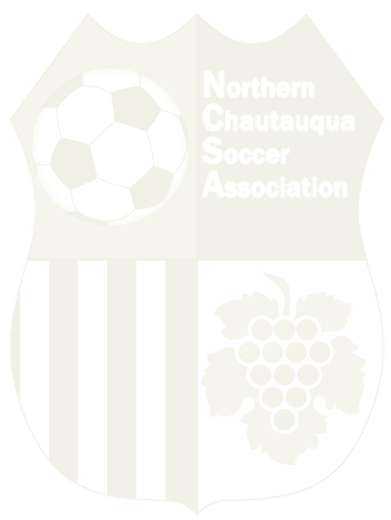
NCSA Application to MODIFY Age Division

NAME: ____________________________ DOB:____________________ AGE: _______

CURRENT TEAM & AGE GROUP: _________________________________________________________

AGE GROUP REQUEST & REASON: ________________________________________________________

Northern Chautauqua Soccer Association requires permission from a parent/guardian for any soccer players to modify his/her age group governed by birth year. An NCSA Board member must also approve this request, in accordance with New York State West Youth Soccer Associations guidelines.

I, as a parent/guardian, am aware that my soccer son/daughter will be playing against older/younger players whose soccer skills are may be more advanced and whose play may be more physical.

As parent/guardian, I give MY PERMISSION for my child, ____________________________________ to modify his/her age group to ______________________________ for the _______________ season in the year of ________.

In granting my permission, I release the above-mentioned soccer organization from all responsibility should my child be injured, no matter how seriously, while a member of the team, and will not hold the above soccer organization liable for any injuries that might occur.

Parent/Guardian Signature:______________________________________________________________

Print Name Date Approved: _____________________________________________________________

Board Member Print Name & Date: _______________________________________________________

