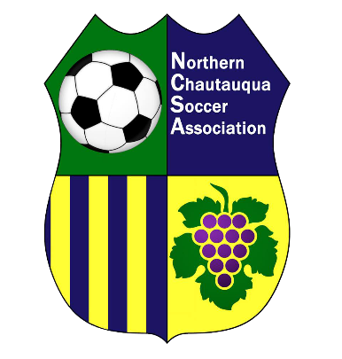
NCSA Annual Membership Meeting
November 5, 2018
SUNY-Fredonia, Fenton Hall, Room 127, 6:30 PM

Minutes

Call to Order
Meeting called to order at 6:30 pm

President’s Report

Treasurer’s Report

State of Soccer

Review of Programs

Election of Officers

- Current seats of office up for election are:
  - President – 2-year term
  - Secretary – 2-year term
  - At-Large Member – 2-year term

Jake Wilkins elected to office of President by vote of 25–0
Cristina Gegenschatz elected to office of Secretary by vote of 25–0
Matt Walker elected to office of Delegate-at-Large by vote of 25–0

Meeting adjourned at 7:30 p.m.

